**Object Oriented Drawing and Painting Application Report**

Name 1: Khaled Hesham Elsayed 6434

Name 2: Ingy M elsakhawy 6477

Name 3 : Karim Gamal Mabrouk 6396

Name 4: Khaled Tahaa Gamea 6116

**Introduction:**

This is drawing application which is developed **by OOP concepts (Inheritance, Polymorphism, Abstraction, Generic concepts).** This application is used to draw basic shapes like Circle, Rectangle, Square and a Straight line. By using this app, you can also fill color in a shape, resize a shape, delete a shape, and you can also drag and drop a shape. This App is based **on MVC (Model View Controller)** and **Memento** pattern.

**Working**

We have a main Single parent Model Called Shape and all other models or children classes are inherits Shape class which is an abstract class.

On the other hand we have Controller, this Controller contains an Object of View and also an Object of Shape

When we have to draw any shape on an Pane We just call a method UpdateView().

And the third thing is View. View Contains A class that updates and handle undo and redo functions and other classes helps it according to momento pattern.

A pane opens on the right side of the screen when user clicks on some shape. When a user right clicks on a specific shape whole lot of options come into play.

It allows user to perform specific functions such as:

* Draw a shape
* Fill color into the shapes
* Delete a shape
* Resize a shape
* Copy paste a shape
* Drag a shape

Design Pattern:

* MVC
* Momento Design Pattern
* Factory Design Pattern
* Strategy Design Pattern

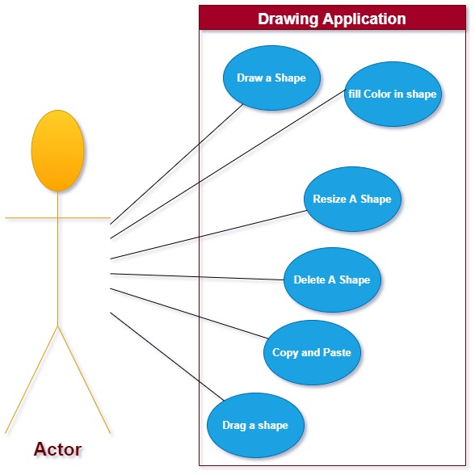Use Case UML:

**UML Class Diagram**

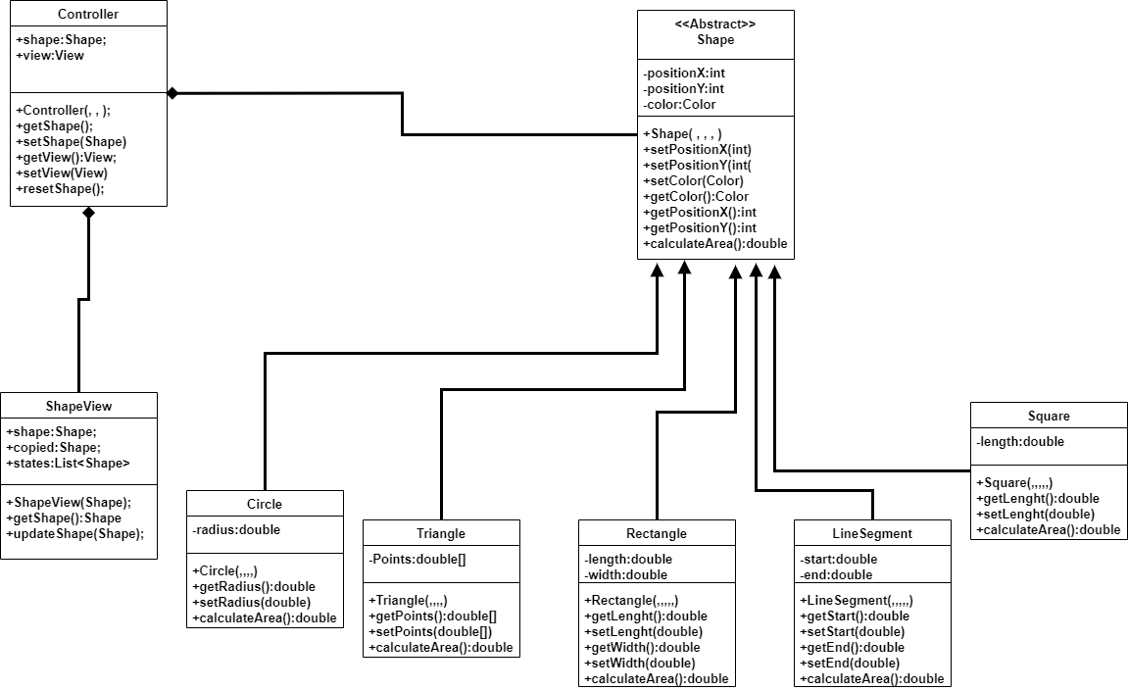

Outputs:

1. 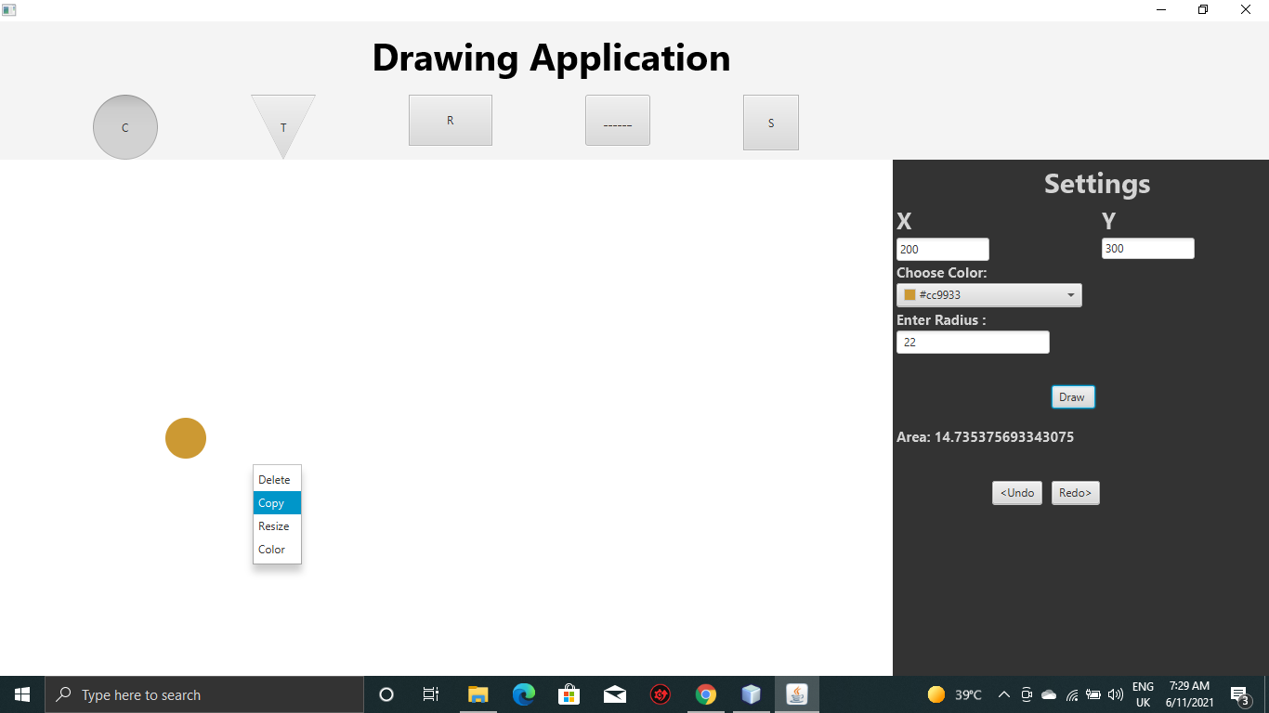 We have drawn a small circle with a color fill.
2. 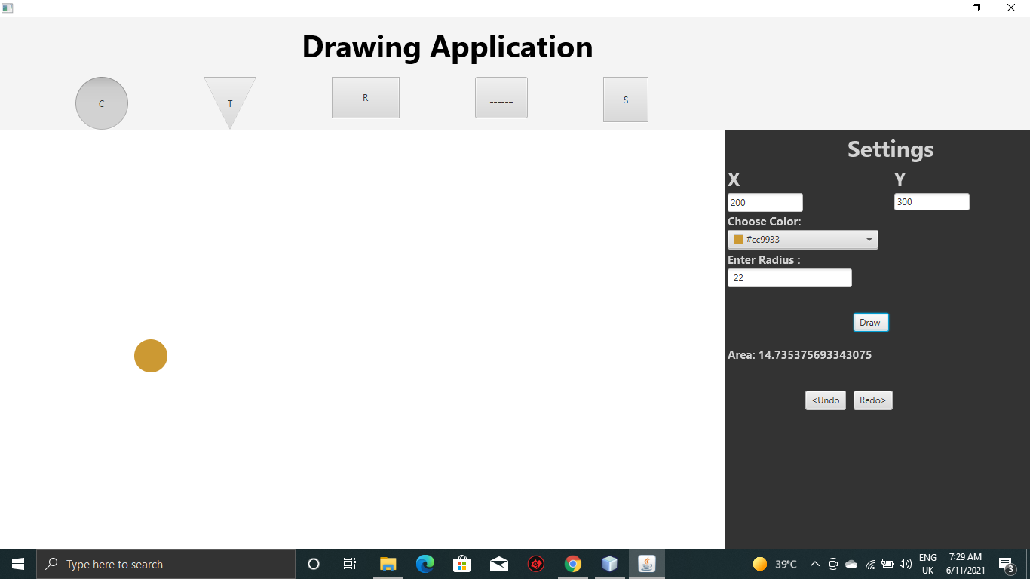Now we have copied this small circle.
3. 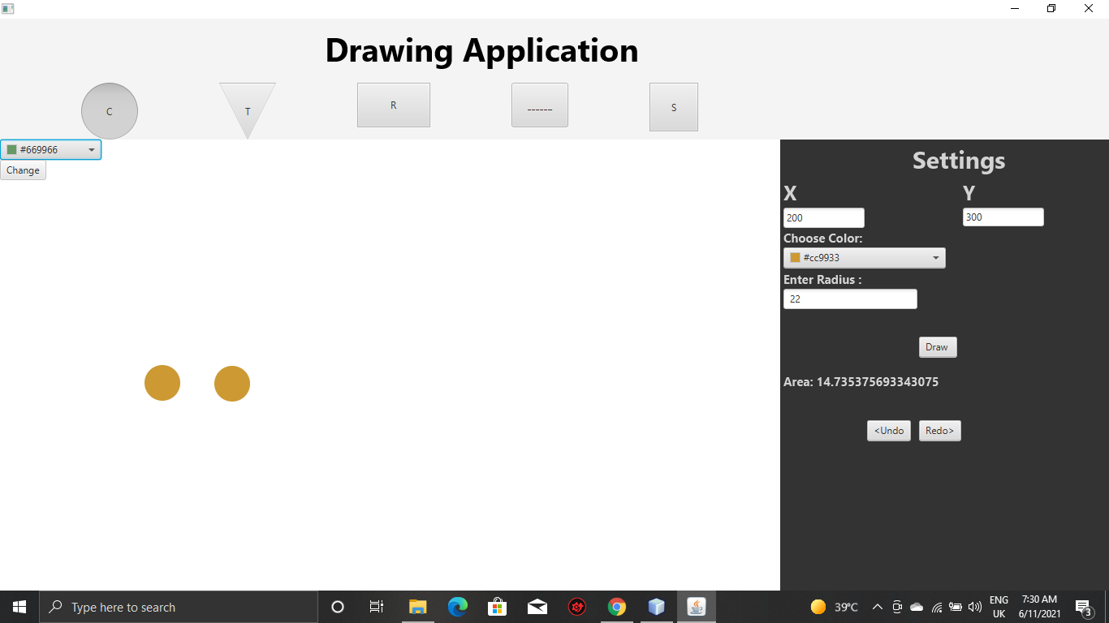Now we have pasted this small circle.
4. Changed the color of pasted circle.

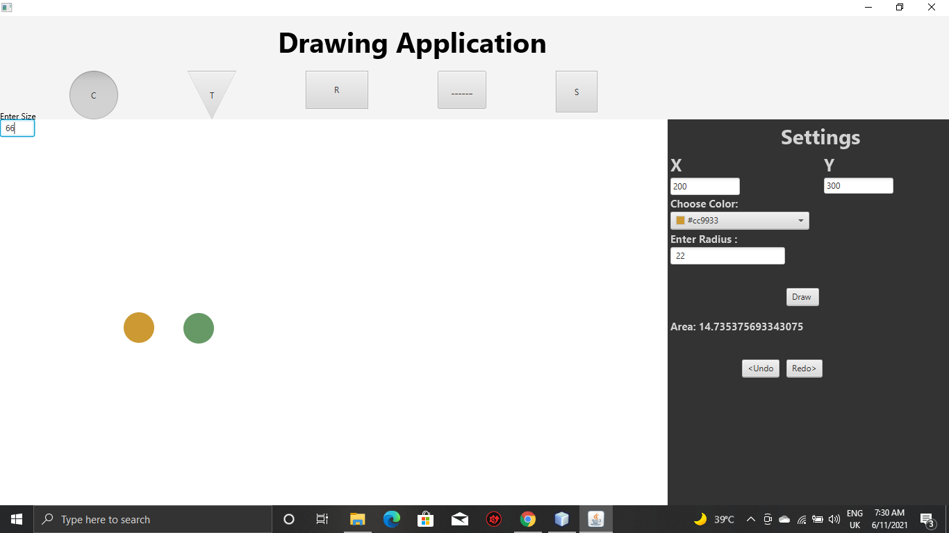

1. Resizing of pasted circle.

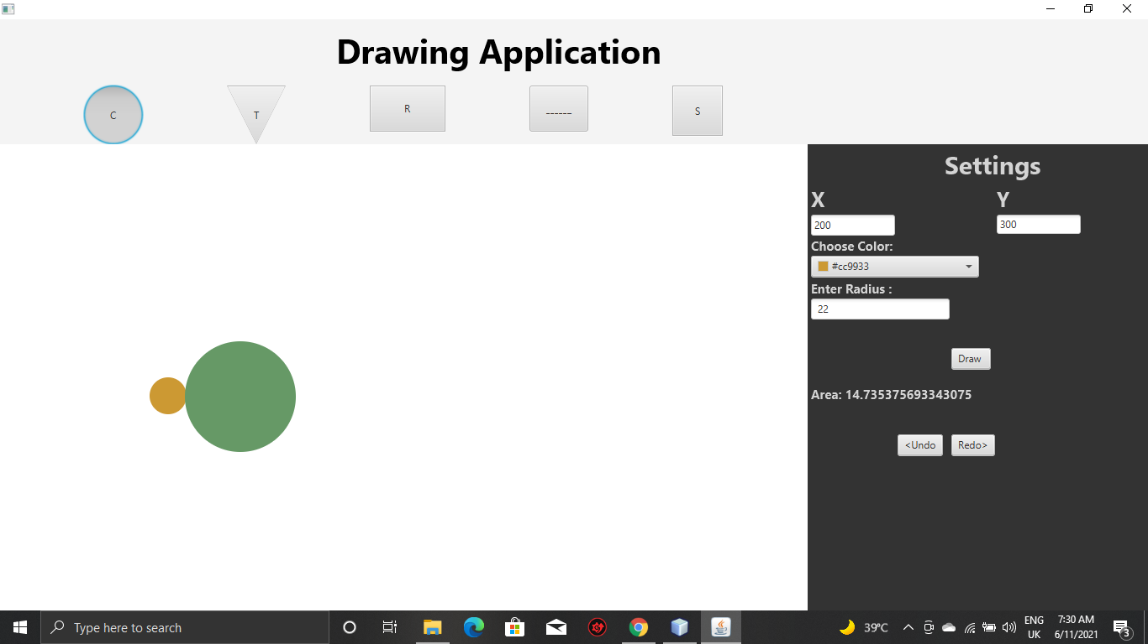

1. 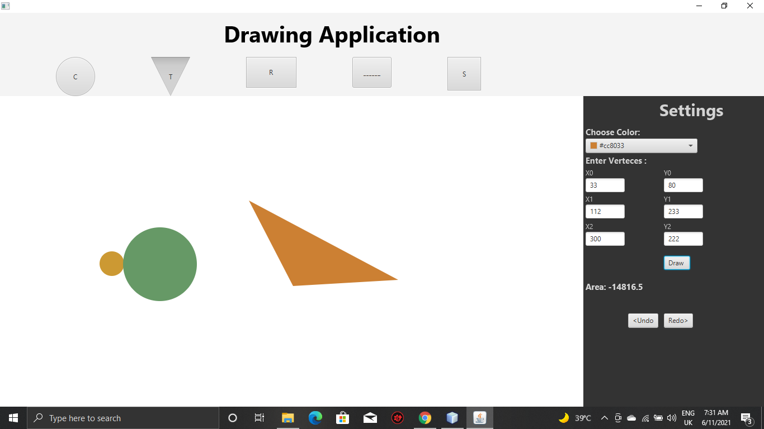Now we have new shape , Triangle with color fill.
2. 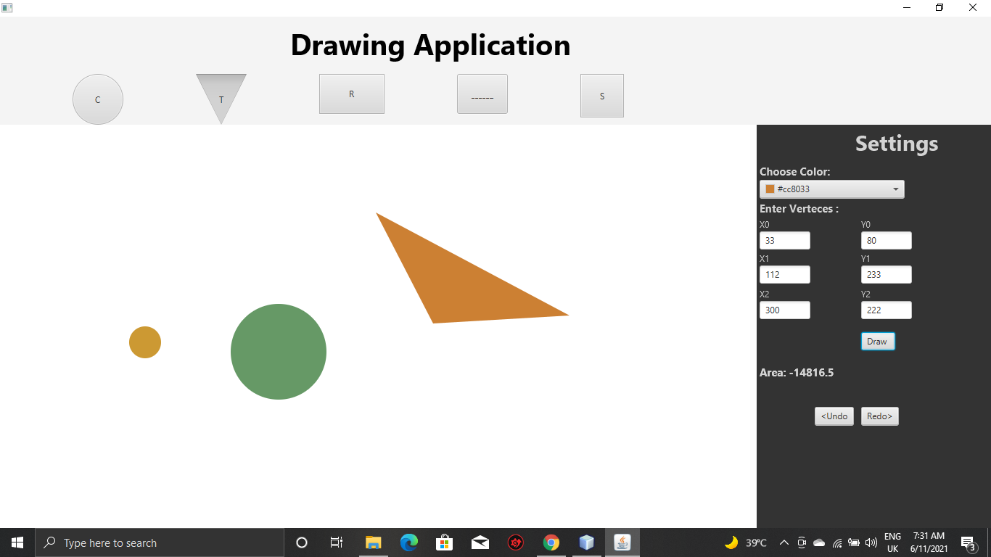Now we have Drag and drop these shapes.
3. 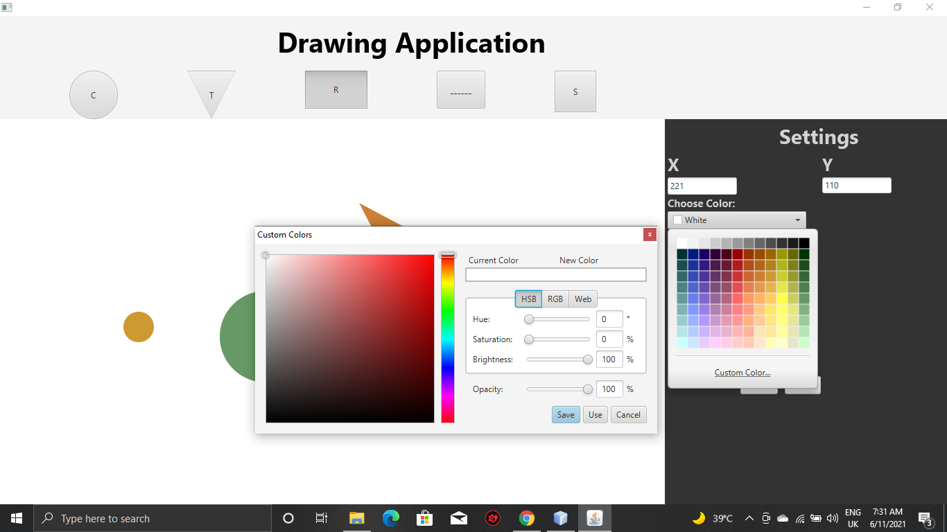Changing the color of Shapes.
4. 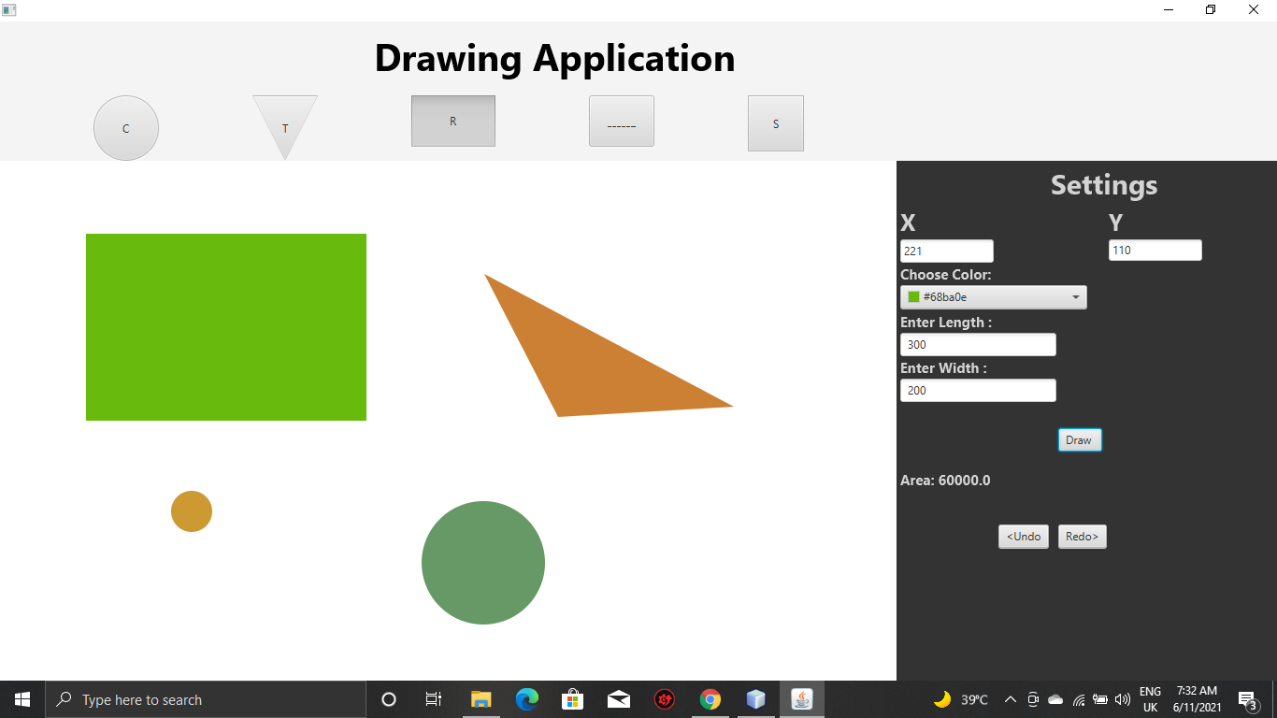Now we have new shape i.e. Rectangle with color fill.

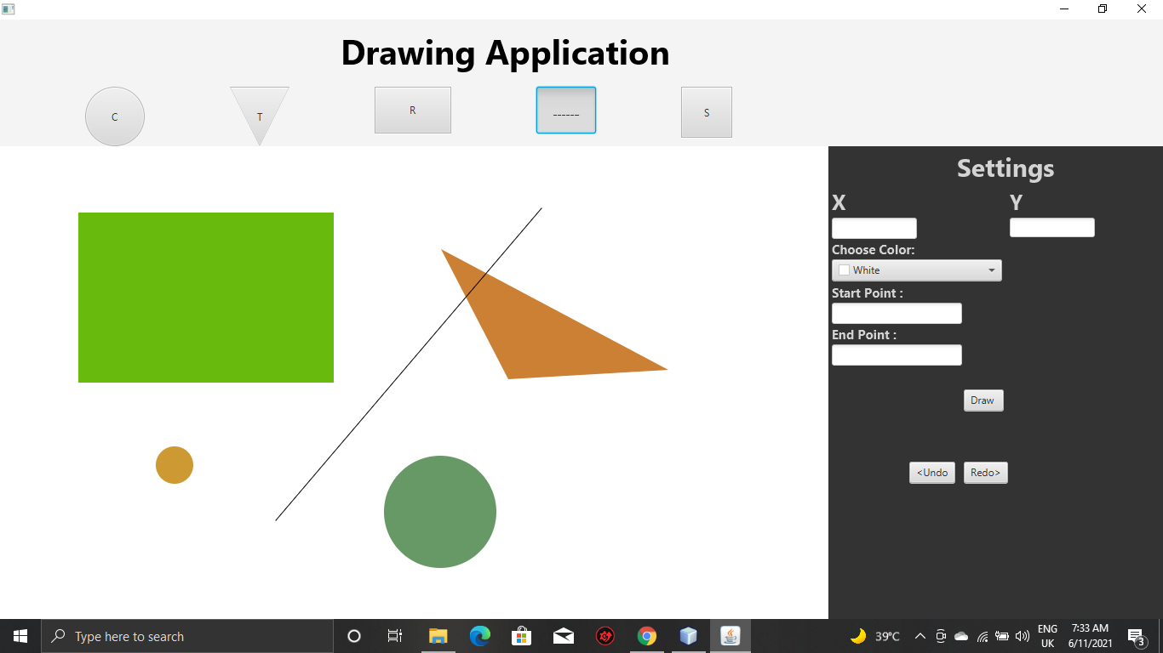10- Now we have new shape i.e. Straight Line with color fill

11-Now we have Drag and drop these shapes.

